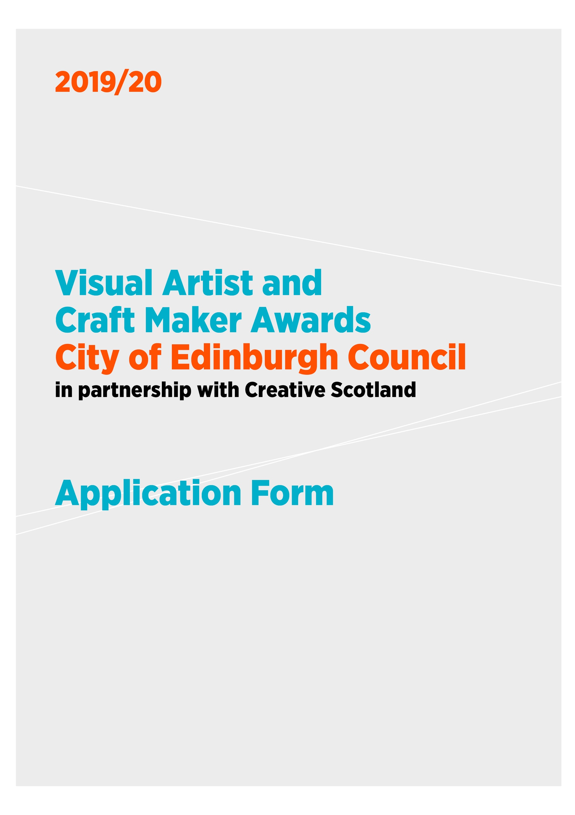

VACMA: EDINBURGH is funded through a partnership between

City of Edinburgh Council and Creative Scotland
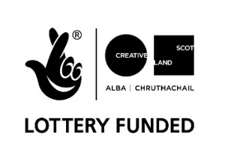

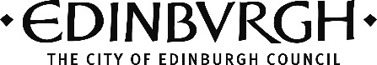

1 APPLICATION DETAILS

Please ensure that you have read the Guidelines carefully before completing the form.

Name:

Address:

Postcode:

Contact telephone number(s):

Email:

website:

Start date:

Expected end date:

Amount of funding requested (between £500-£1,500):

OR

I am applying for the New Graduate / Emerging Artist Bursary of £500

Artform tick one box only
Visual Art
Craft

2 SUPPORTING INFORMATION

- Please submit a copy of your current artist CV (this helps us to understand what you have achieved so far in your practice, your training and track record). You may also include your artist statement.

- If you are applying for support for the development of work for an exhibition or for a residency, please provide a letter of support from the gallery / organisation which explains what they will be providing

- Please submit up to 6 high quality images or up to 5 minutes of film/sound files

- Please complete the Equalities Monitoring form
3 ABOUT YOU

Please tell us briefly about your practice.
What do you do and why do you do it? Max 250 words

What do you want funding for? Max 500 words

How will this develop your practice and what do you want to achieve in the long term?
Max 250 words

Is there any public element to the proposal? e.g. an event, performance or exhibition. If yes, tell us more about it. Max 200 words

Please give an outline and timetable (including dates) of the key stages and any preparation work you have done.

4 PREVIOUS APPLICATIONS

Have you had a VACMA, or Creative Scotland award before? If so, when?

If you have, please tell us how that support helped your practice, and whether this is a continuation of that project.

Priority in awards may go to those who have not previously been successful in the scheme. Applications will not be considered from previously successful applicants who have not yet submitted their End of Project Report.

5 PLACE

How long you have been resident in the area?
If you are not resident please say why you are applying to this scheme in this area.

6 BUDGET

Please provide a budget breakdown for your project, detailing the grant requested, your own financial contribution and any other sources of funding. Please indicate if these are cash or in-kind contributions and ensure in-kind is accounted for in both income and expenditure. If the cost exceeds £1,500, please include other sources of income and funding, showing which have been confirmed at time of application.

Expenditure - Breakdown of Estimated Project Costs

item | cost £ | Cash or in-kind
Total Cost of Project

Income – this figure should equal your expenditure above

 | £ | Confirmed  Cash or in-kind
Grant request from Award Scheme:
Own cash contribution:
Other sources of income (if applicable):
Total Estimated Income for Project:

The focus of this fund is to support new opportunities for creative development and the change this can bring to your practice. Whilst we recognise that artists/makers time is crucial to creating new work or undertaking professional development activities we are not able to support day to day living costs or replace other income.

For the purposes of this application any time contribution is viewed as in-kind contribution and part of your professional practice. However, we would like to better understand the nature of this contribution so please provide the following information:

Number of days you intend to spend on this project:

7 ARTWORK SUBMISSION FORM

Name:

Image format:
(jpeg on CD, DVD, USB, etc)

Please enter details of the artwork submitted in support of your application. We cannot accept original artwork. Please read ‘How to Apply’ notes on the guidance form.

We request that all supporting material is clearly labelled with your name and the title of works.

 | Images/ Work Title | Date | Size | Medium and Description
1
2
3
4
5
6

Please note we cannot accept responsibility for damage to or loss of material submitted in support of applications, although we will exercise all possible care in handling this material.

We are committed to protecting the rights and privacy of individuals in accordance with the Data Protection Act 2018. We need to process certain information about our staff, customers, and other individuals that we have dealings with for administrative purposes. We will also share the information provided with Creative Scotland as the funding partners to support evaluation, assessment and development. To comply with the Act, information collected about individuals must be used fairly, stored safely and securely and not disclosed to any third party unlawfully. Data Protection Act - The DPA 2018 sets out the framework for data protection law in the UK. It updates and replaces the Data Protection Act 1998, and came into effect on 25 May 2018. It sits alongside the GDPR, and tailors how the GDPR applies in the UK.

DECLARATION

I (print full name) _____________________________________ hereby apply for financial assistance towards the cost of undertaking the project described in this application. To the best of my knowledge and belief, the information given is correct.

Signature:

Date:

Please ensure that: | Tick
All questions have been completed on the application form.
An up to date C.V is included in the application.
Artwork - up to 6 good quality images or if submitting short film - a web link. Please ensure that artwork is clearly labelled and corresponds to the Artwork Submission Form.
The Artwork Submission Form is completed.
The VACMA Equalities Monitoring Form is completed.
The application is signed.

If you would like to have an initial chat before putting in an application (advisable) or have any queries relating to your application please contact Jo Navarro, Cultural Development Officer, on 0131 529 6716 or via email jo.navarro@edinburgh.gov.uk .

Applications will not be processed unless all the documents and support materials are received.

An electronic copy of the application with supporting materials should be sent to
culturaldevelopment@edinburgh.gov.uk. Or to jo.navarro@edinburgh.gov.uk if sending via WeTransfer or Dropbox

If you would like to subscribe to the mailing list to receive email alerts on opportunities/funding for visual artists/craft makers please tick the box

PRIVACY NOTICE

The Visual Artist & Craft Maker Awards (Edinburgh) application form asks for personal details about you. By signing this form you are granting permission for the City of Edinburgh Council to process any personal data you have provided in order to: (i) process and assess your application; (ii) work with you if your application is successful; (iii) collate information for statistical and audit purposes; (iv) update details we already hold for you.

The City of Edinburgh Council will use the information you have provided on the application form and on any other associated forms, together with other information the Council may obtain about you, (“Personal Data”) to carry out security checks in connection with your application(s); to assess your eligibility for a grant(s) and for administration and management purposes and for statistical analysis. The City of Edinburgh Council may disclose your information to City of Edinburgh Council’s Auditors and other professional advisers for these purposes. It is important you understand that providing false information may be a criminal offence. The information you submit on your application will be used to;

- Process and assess your application;
- Work with you if your application is successful;
- Collate information for statistical and audit purposes;
- Update details we already hold for you.

How long will my information be retained for?
If your application is unsuccessful the City of Edinburgh Council will retain your Personal Data for three years in accordance with legal requirements and for administration purposes. If your application is successful City of Edinburgh Council will retain your Personal Data for seven years in accordance with the Council’s Corporate Records Retention Schedule and for administering, processing and assessing your application.

Third Parties we work in association with.
We have a contractual agreement with Creative Scotland to provide Visual Artist & Craft Maker grants. In some cases, Creative Scotland will be acting as a data controller of your information and therefore we advise you to read their Privacy Notice. If you wish to view these, you should use the contact details below to make your request.

Creative Scotland: enquiries@creativescotland.com
Telephone: 0845 603 6000

The personal data received from all applicants will be shared with Creative Scotland to create and produce reports for Creative Scotland to fulfil its responsibilities to the National Lottery and the Scottish Government. Creative Scotland may also use your data to publicise the grants awarded through the media or other means.

Your personal data will also be used and shared for evaluating your application by the Assessment Panel which may include artists and arts practitioners including representatives from City of Edinburgh Council and Creative Scotland and if successful, for the purpose of awarding and paying a grant to you. The information shared will be the personal and proposed project information on your application form.

You can view the City of Edinburgh Council’s Privacy Notice by visiting www.edinburgh.gov.uk/privacy

